Currently Big Mountain Resort ticket price is 81.00 but can increase by $1.99 to $10.39. Big Mountain has many facilities in which they excel. Big Mountain is doing well for vertical drop, snow making area,highest number of total chairs, fast quads,largest amount of skiable terrain and one of the longest runs.

Graphs 1 - 7 demonstrates that Big Mountain resort is one of the resorts in the spectrum which provides the best facilities. These facilities support an increase in ticket value and, also, an opportunity to cut cost without undermining the ticket, as demonstrated in graph 8.

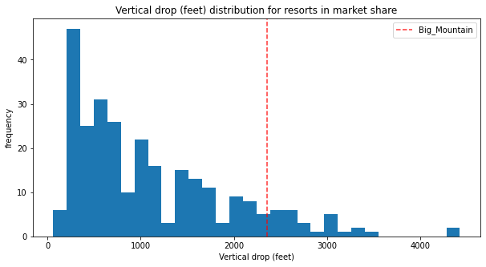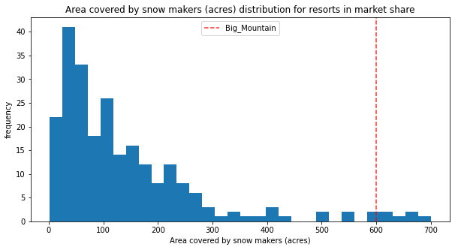

Graph 1. Big Mountain is doing well for vertical drop. Graph 2. Big Mountain is very high up the league table of snowmaking area.

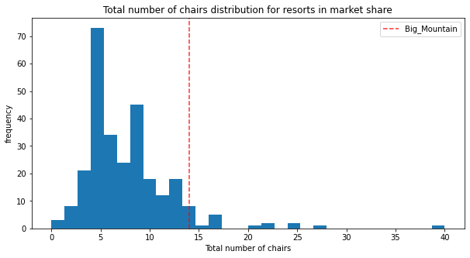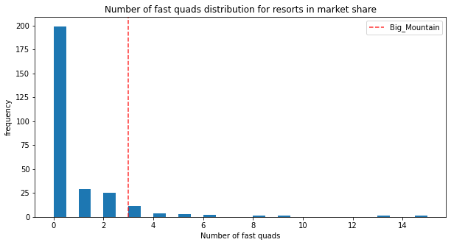

Graph 3. Big Mountain has the highest number of total chairs. Graph 4. Big Mountain has the most fast quads.

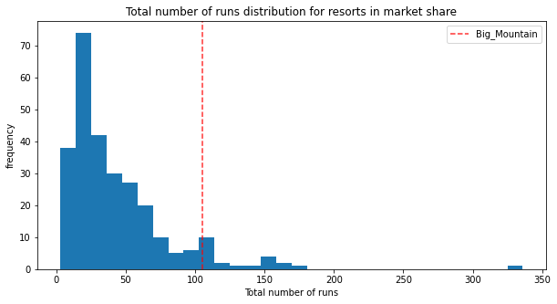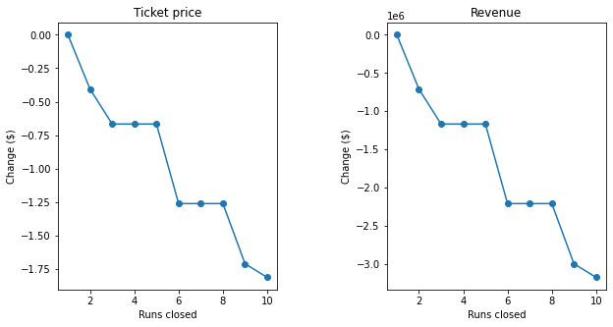

Graph 5. Big Mountain compares well for the number of runs. Graph 6. Supports the closure of 4-5 runs.

I would suggest closing down up to 4 runs and increasing the vertical drop by 150 feet and installing a new chair lift. It increases the ticket price by 1.99 with an expected amount of $3474638 over a season. Operating the new chair could be covered by the cost of the increase of the ticket price which would value to $3474638 in the first season alone if a visitor on average buys 5 day tickets. I recommend permanently closing down the 3-4 less used runs for the first season and then permanently closing them if you are satisfied with the first season. Big Mountain is one of the resorts that has the most runs, so closing down these runs will not drop the ticket price.